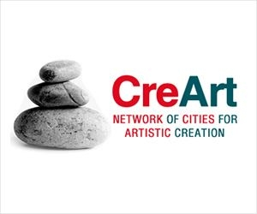
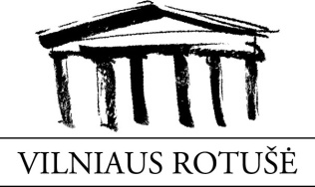

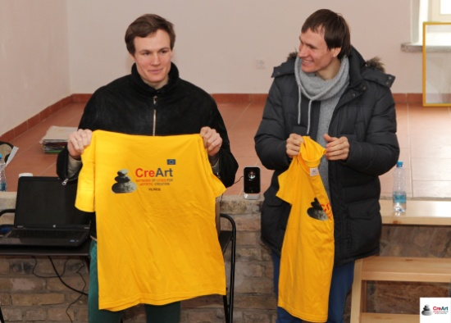
The 15th of April at 15.00 pm. The Town Hall (Vilniaus Rotušė) invited to visit Užupio, where gathered a group of lovers of art and creative ways. "Užupio meno inkubatoriuje" (UMI) was the place where took place the creative workshops belonging to the European project CreArt, where the guests-artists were Algirdas and Remigijus Gataveckas.
The artists Algirdas and Remigijus Gataveckas explain us their large-scale project, "Effects", consisting of five life-size photorealistic portraits of young people living in the Alytus Child Care Home. This project garnered Gataveckas both the Lithuanian Young Artist award and the ARTVILNIUS'12 audience prize. The brothers decided to sell these drawings and all of the money was donated to the Alytus Child Care Home, where Gataveckas brothers are continuing to work on his project. The Alytus Child Care Home is also where both twin brother grew up.
In the workshop, the artists talked about his creative sense and how it had been born, furthermore, the explain us how and why they used such techniques in his works, how was the creative process...
The brothers revealed the stories that each creation of paintings have it, providing even greater value at their work. Forcing to think and look at their works again, with another glance.
Time passed unnoticed with the creators, workshop participants showed interest, asked questions, and joined to the discussion with the artists. At the end of the workshop brothers Gataveckas demonstrated one of his techniques - painting a portrait in 3.5 seconds without lifting the pencil and move the paper, and what is more amazing still, without looking at the portrait. Such skill left a great impression on the workshop participants.
It was a very interesting and fun workshop. Their work is creative and original with a social background. We would like to support these two Lithuanian young talents to they continue with their great work.

Vilniaus rotušė

